**ANAND INSTITUTE OF HIGHER TECHNOLOGY**

**OLD MAHABALIPURAM ROAD,**

**KALASALINGAM NAGAR,**

**KAZHIPATTUR,**



**Traffic Management**

**using IoT**

**Phase – V**

**Name : Neelraj. S**

**Reg No. : 310121104068**

**Branch : COMPUTER SCIENCE & ENGINEERING**

**Year/Sem : III / V**

**INTERNET OF THINGS**

**PROJECT: Traffic Management**

**Project ID: proj_229787_Team_2**

**TEAM MEMBERS :**

* **Sri Arvind M**
* **Neelraj S**
* **Rajesh D**
* **Arindran M**
* **Naraayanan T**

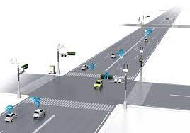

**TRAFFIC MANAGEMENT**

1. **Introduction:**

The proposed project aims to address the growing problem of traffic congestion in urban areas by leveraging the power of Internet of Things (IoT) devices and data analytics. The project focuses on creating a system that monitors traffic flow in real-time and provides commuters with access to this information through a public platform or mobile applications. This will empower commuters to make informed decisions about their routes, ultimately reducing congestion and improving overall traffic efficiency.

1. **Problem Statement:**

The project involves using IoT devices and data analytics to monitor traffic flow and congestion in real-time, providing commuters with access to this information through a public platform or mobile apps. The objective is to help commuters make informed decisions about their routes and alleviate traffic congestion. This project includes defining objectives, designing the IoT traffic monitoring system, developing the traffic information platform, and integrating them using IoT technology and Python.

1. **Problem Solution:**

We need to find modern solution for this traffic Internet of Things (IoT) devices offers a promising avenue to revolutionize how we monitor and regulate traffic flow. By deploying a network of smart sensors, cameras, and connected devices at strategic points within urban areas, we can gather real-time data on Humidity and temperature near traffic signals and to adjust the traffic signals dynamically depending upon the traffic congestion on the road by increasing the duration of time for the vehicle to pass on. By this we can move on towards more sustainable and efficient urban transportation networks.

**IoT:**

IoT, or the Internet of Things, refers to a network of interconnected devices, objects, and systems that can communicate and exchange data with each other over the internet. These "things" can include a wide range of physical objects, such as sensors, cameras, appliances, vehicles, and more, that have been equipped with sensors, actuators, and connectivity capabilities (like Wi-Fi, Bluetooth, or cellular networks).

The key concept of IoT is the ability of these devices to collect and exchange data without human intervention. This data can be anything from temperature, location, and motion to more complex information like health metrics, environmental conditions, or machine performance. This data is then typically sent to a central server or cloud platform for storage, processing, and analysis.

IoT technology has a wide range of applications across various industries, including smart homes, healthcare, transportation, agriculture, industrial automation, and more. It has the potential to enhance efficiency, automation, and decision-making in many aspects of our daily lives and various industries.

**TABLE OF CONTENT**

1. **Introduction**
2. **Phase - I**
3. **Phase - II**
4. **Phase - III**
5. **Phase – IV**
6. **Introduction to phase V**
7. **Introduction to Blynk Api**
8. **Introduction to MIT**
9. **Code & Prototype**

**10. Sample Output**

**11. Conclusion**

**Phase-I:**

The project aims to address urban traffic congestion using IoT devices and data analytics for real-time traffic monitoring. This involves providing commuters with access to accurate traffic information through a public platform or mobile apps. The primary objectives include real-time traffic monitoring, congestion detection, route optimization, and an improved commuting experience.

**1. IoT Sensor Design:** The objective of this phase is to strategically deploy IoT devices (sensors) to collect real-time data on traffic flow and congestion. This involves identifying suitable sensors, such as cameras, GPS trackers, and traffic flow sensors, capable of providing accurate and reliable data. The deployment strategy will determine optimal sensor locations at key traffic points, considering factors like visibility, power supply, and connectivity. Additionally, selecting appropriate communication protocols (e.g., Wi-Fi, Bluetooth, or cellular networks) for data transmission from sensors to the central server is crucial.

**2. Real-Time Transit Information Platform:** The objective here is to develop a user-friendly web-based platform and mobile applications to display real-time traffic information to the public. This involves designing an intuitive interface with interactive maps, traffic visualizations, and route recommendations. Data integration mechanisms will be implemented to receive, process, and display data from IoT sensors in real-time.

1. **Integration Approach:** The objective of this phase is to seamlessly integrate the IoT traffic monitoring system with the real-time transit information platform. This involves establishing a data pipeline for transmitting and processing traffic data from IoT sensors to the platform. Python will be the primary programming language chosen for its versatility and compatibility with IoT technologies. The development of APIs will facilitate communication between the IoT system and the platform. Thorough testing will be conducted to ensure smooth data flow and integration.

**Conclusion:** Following this structured approach, we aim to create a comprehensive solution addressing traffic congestion through IoT-based real-time traffic monitoring.

**Phase-II:**

To further elevate the effectiveness of our traffic management solution, we propose the integration of historical traffic data and gaining knowledge about IoT sensors . This innovative approach aims to predict congestion patterns, providing commuters with even more accurate and proactive information for their journeys. By leveraging historical data alongside real-time monitoring, we can enhance route optimization and alleviate traffic congestion in urban areas.

* **Integration of Historical Traffic Data:**

**Objective:** Understand best practices for aggregating and utilizing historical traffic data

**Research Areas:**

* **Data Sources:** Investigate sources of reliable historical traffic data, including government databases, traffic management systems, and transportation authorities.
* **Data Preprocessing:** Explore techniques for cleaning, transforming, and enriching historical data for effective analysis.
* **Feature Engineering:** Learn methods for extracting relevant features that contribute to accurate congestion predictions.
* **Gaining In-Depth Sensor Knowledge:**

**Objective:** Acquire detailed knowledge about the sensors deployed in the traffic management system.

**Research Areas:**

* Sensor Types and Specifications: Research and understand the different types of sensors (e.g., cameras, traffic flow sensors) and their capabilities in collecting traffic data.
* Calibration and Maintenance: Explore best practices for calibrating and maintaining sensors to ensure accurate data collection.
* Data Interpretation: Gain expertise in interpreting sensor-generated data to extract meaningful insights for traffic management.
* **Emerging Technologies and Trends:**

**Objective:** Stay updated on the latest technologies and trends in traffic management for potential enhancements.

**Research Areas:**

* **Emerging Sensor Technologies:** Investigate new sensor technologies (e.g., LiDAR, advanced cameras) and their potential applications in traffic monitoring.
* **Advanced Data Analytics Techniques:** Explore cutting-edge data analytics methods for improved traffic prediction and management.
* **Conclusion:**

By conducting comprehensive research in these areas, we aim to equip ourselves with the knowledge and expertise needed to successfully implement the proposed traffic management design. This research plan will serve as a foundation for making informed decisions and executing the project effectively.

**Phase-III:**

In Phase 3 of our project, we embarked on the implementation of a design integrating key sensors to enhance our traffic management system. Leveraging the capabilities of the HC-SR04 ultrasonic sensor, DHT-22 temperature and humidity sensor, and the ESP-32 microcontroller, we aimed to elevate the system's data collection capabilities. This strategic integration enables us to gather critical environmental data in real-time, providing valuable insights for traffic monitoring and congestion prediction. The utilization of these sensors marks a pivotal advancement in our endeavor to create a robust and intelligent traffic management solution.

* **Sensors Used:**

1. **Ultrasonic Distance Sensor - HC-SR04 (5V)**
2. **DHT-22 AKA AM-2302**
3. **ESP-32**

**HC-SR04:**

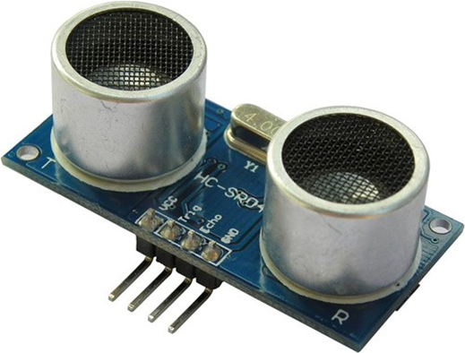

The HC-SR04 Ultrasonic Distance Sensor is a popular and affordable sensor used for measuring distances. Operating at 5V, it works on the principle of sending ultrasonic waves and calculating the time it takes for them to bounce back after hitting an object. This data allows you to accurately measure distances, making it a valuable component in various applications like robotics, obstacle detection, and proximity sensing. Its simplicity and reliability make it a go-to choice for many electronics enthusiasts and engineers.

**DHT- 22:**

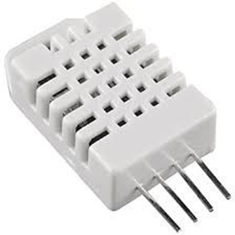

The DHT22 is a digital-output relative humidity and temperature sensor/module that provides accurate readings for both parameters. Also known as the AM2302, it offers a wide operating voltage range and communicates through a single-wire digital interface, making it relatively easy to integrate into projects. With its precision and compatibility, the DHT22 is a favored choice for weather stations, home automation, and IoT applications, enabling you to monitor and control indoor environments effectively.

**ESP-32:**

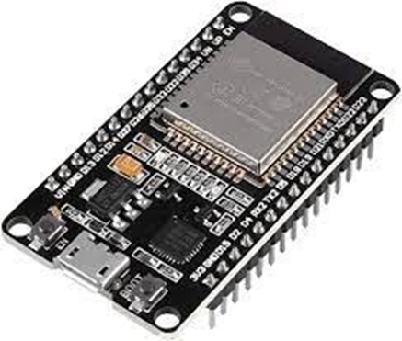

The ESP32 is a highly versatile microcontroller and wireless communication module developed by Esp ressif Systems. It features dual-core processors, Wi-Fi, and Bluetooth capabilities, making it a powerful and popular choice for IoT and embedded systems. With its extensive GPIO pins, low power modes, and compatibility with the Arduino IDE, the ESP32 is a go-to platform for a wide range of projects, from connected devices to robotics and automation, owing to its flexibility, connectivity options, and developer- friendly ecosystem

Using the above mentioned Sensor we constructed a design in the web-platform WOKWI.

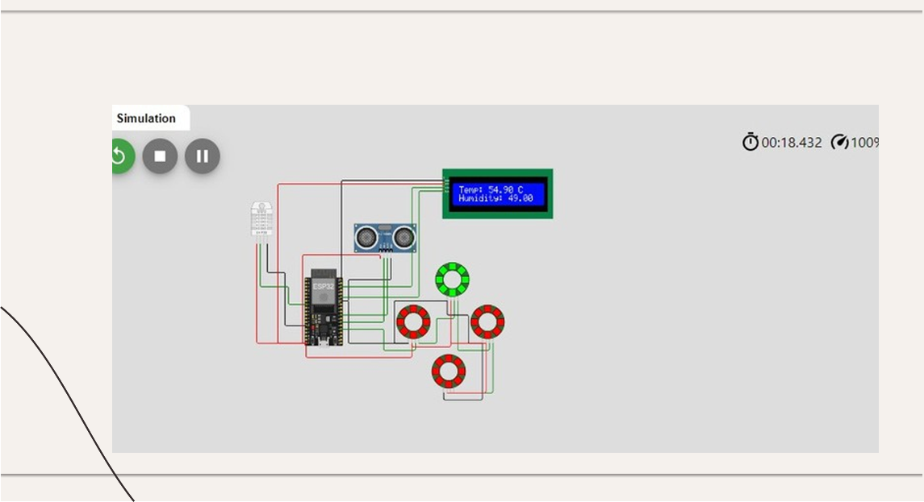

The above design works When congestion exceeds a predefined threshold, our system dynamically adjusts signal timings, extending green light durations as needed. This intelligent solution reduces wait times, eases congestion, and ultimately optimizes the overall traffic management experience. Through this innovative approach, we are poised to make significant strides in alleviating urban traffic woes.

**CONCLUSION:**

In conclusion, this project demonstrates the successful implementation of smart traffic management using ultrasonic sensors and the HC-SR04 sensor module. By dynamically adjusting traffic signal timings based on congestion, we've shown a promising solution to reduce waiting times and alleviate traffic congestion at junctions. Moving forward, we plan to enhance and expand this project using Raspberry Pi technology, which will provide more computational power and connectivity options to further optimize traffic control and explore additional smart city applications.

**PHASE-IV:**

In this Phase, we aim to dynamically adjust the timing of traffic signals by analyzing the traffic using sensors such as HC-SR04, DHT-22, and ESP32. Building upon the previous phase, we have upgraded our model from ESP32 to Raspberry Pi for enhanced performance and capabilities.

**Raspberry Pi:**

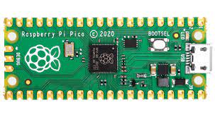

The Raspberry Pi is a powerful microcomputing device that has revolutionized the world of embedded systems. With its compact size and low cost, it provides the perfect platform for our traffic signal timing algorithm.affordable single-board computer developed by the Raspberry Pi Foundation, a UK-based charity organization. It was designed to promote computer science education and programming skills in schools and developing countries. The Raspberry Pi has gained widespread popularity due to its versatility, low cost, and ease of use.

In this Phase we have replaced the ESP-32 microcontroller by Raspberry pi microcontroller and created a web-page for the device to be used and gain knowledge about our project

The websites is a dynamic web-page ,which is designed using HTML & CSS , it contains our project details and the prototype of our project

Images of the website is mentioned below:

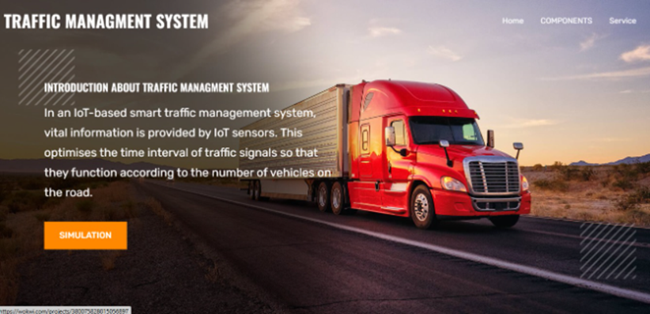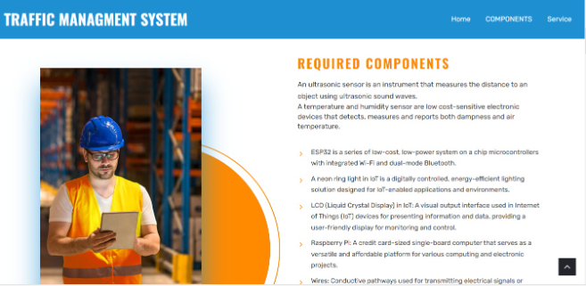

**CONCLUSION:**

As we move forward, the addition of cloud connectivity will enable us to take our traffic signal timing system to new heights. By transferring data to the cloud, we create opportunities for advanced analysis and real-time optimization. Together, we can revolutionize the way traffic is managed, creating safer, more efficient road networks for all.

**PHASE-V:**

In this Phase we are integrating cloud connectivity to our device , by this we can get seamlessly transferring data to the cloud, we unlock a realm of possibilities for sophisticated analysis and real-time optimization. This pivotal step allows us to revolutionize the way traffic is managed, paving the way for safer and more efficient road networks that benefit all members of our community. Together, we embark on a journey towards a future where traffic management reaches unprecedented levels of effectiveness and intelligence.

In this Phase we are using the same sensors which we used in the phase 3 (HC-SR04,DHT-22 & ESP-32) and we are connecting the device with an API (Application Program Interface) called **BLYNK RESTFUL API**

**CODE:**

Here is the code we are using for dynamically adjusting the signal timing using the IoT sensor and the following code

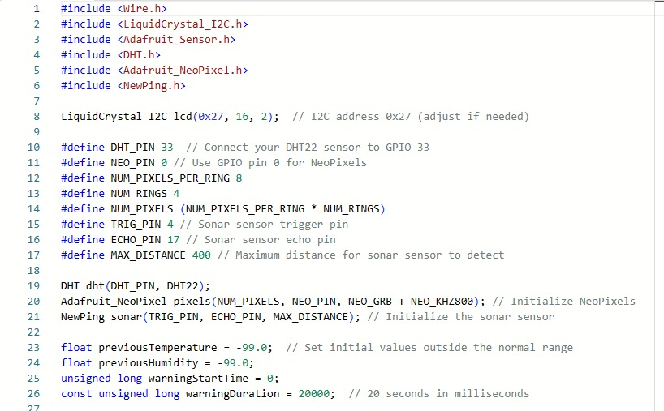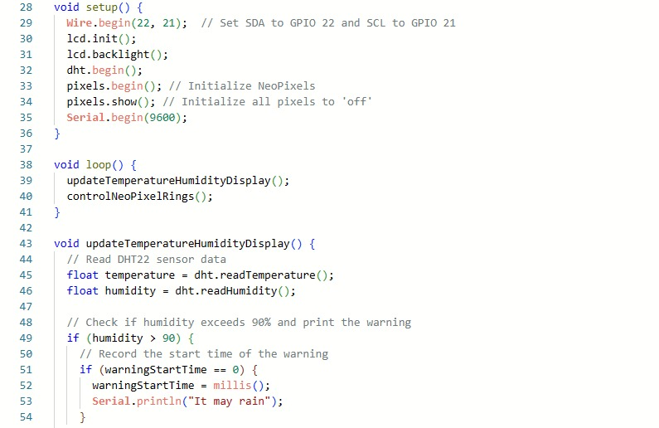

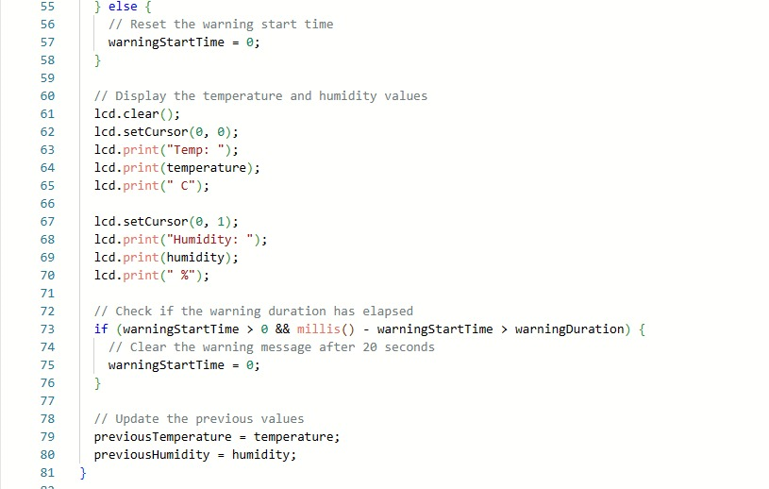

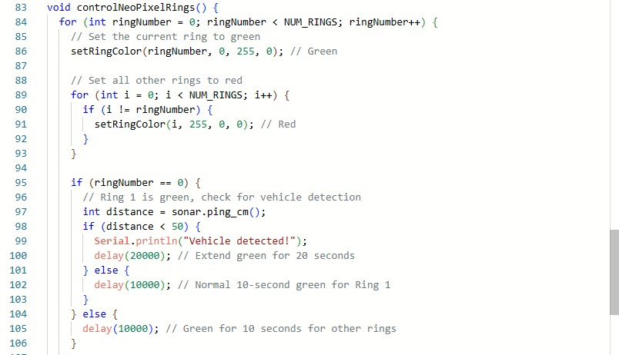

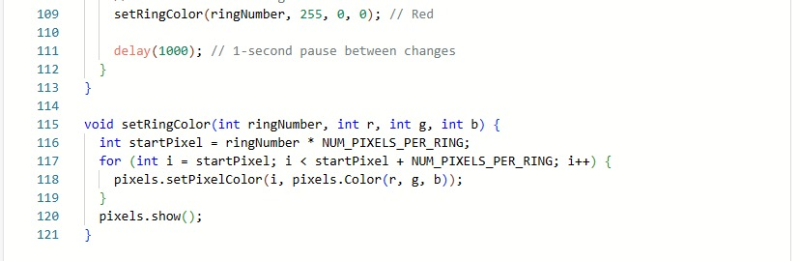

By the above code we can dynamically adjust the signal timing by analysing the traffic congestion

And the following code will help you to link it with the Blynk.

**BLYNK API:**

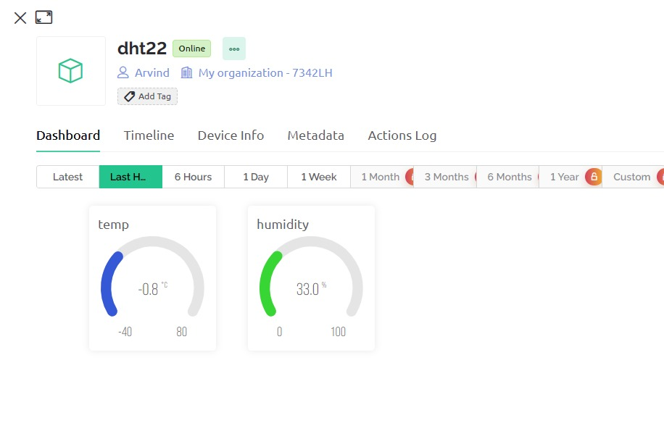

The Blynk RESTful API is a powerful tool provided by the Blynk platform that allows users to interact with their IoT (Internet of Things) projects and devices. Blynk is a popular IoT platform that enables users to build and control connected hardware applications using a simple and intuitive interface.

The RESTful API in Blynk provides a set of HTTP-based endpoints that allow users to perform various operations such as controlling pins, reading sensor data, sending notifications, and more, programmatically. This API facilitates seamless integration with other software and services, enabling users to create custom applications and automation systems that interact with their Blynk projects.

**Key features:**

**1.**Authentication: The API requires authentication using an authentication token generated for each Blynk project. This token serves as a key to authorize API requests.

**2.**Control Pins: Users can control the state of virtual and physical pins in their Blynk projects through API requests. This enables remote operation of connected hardware components.

**3.**Read Sensor Data: Users can retrieve sensor readings and other data from their IoT devices by querying specific pins through the API.

**4.**Notifications: The API allows users to send notifications to their Blynk app, providing alerts or updates based on specific events or conditions.

**5.**Energy Management: Users can check their remaining energy balance and monitor energy consumption using the API.

**6.**Project Configuration: The API provides endpoints for accessing project details, such as the list of available widgets and their properties.

**7.**Device Information: Users can retrieve information about the hardware devices connected to their Blynk projects, including their status and properties.

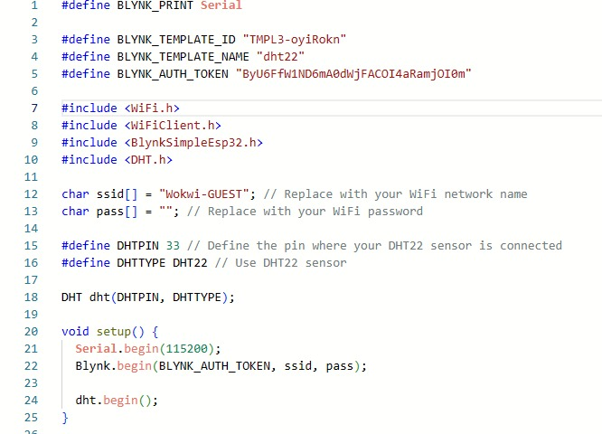

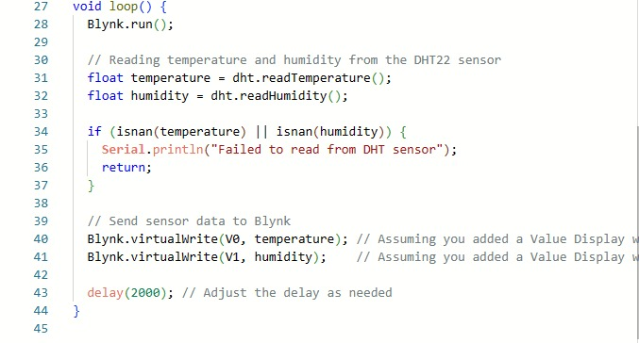

By the above code we can connect the device to the Blynk API.

**PROTOTYPE:**

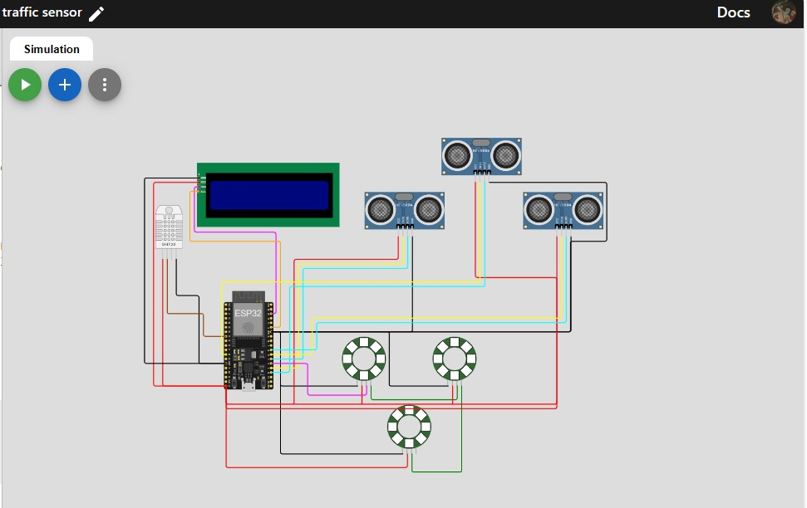

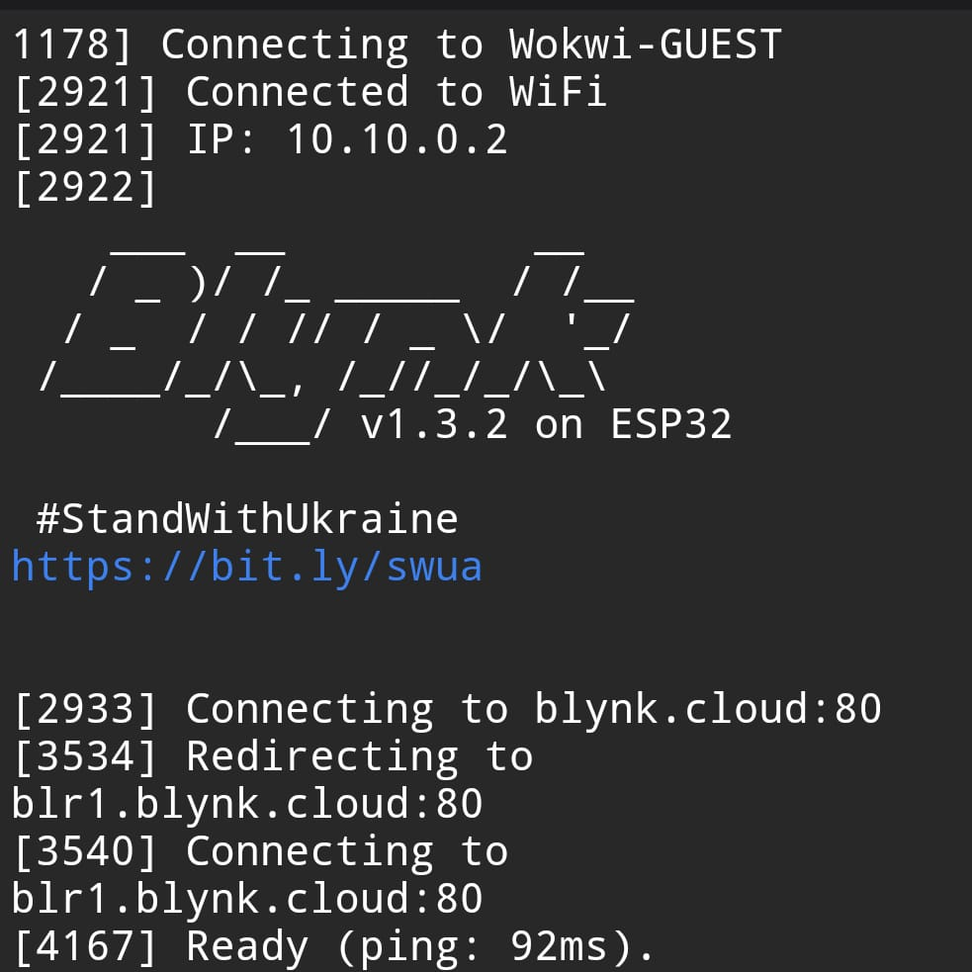

We can view the real time data that the sensor detects using Blynk

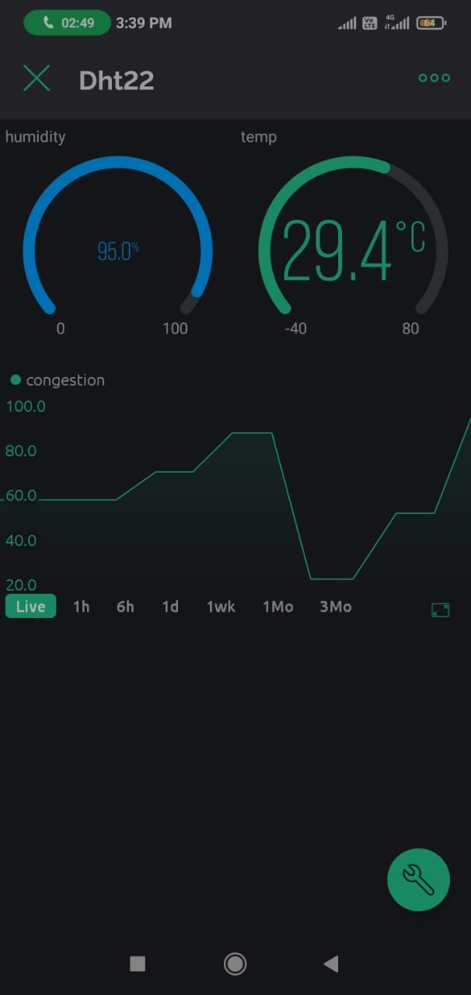

**MIT:**

MIT App Inventor is an intuitive, visual programming environment that allows users to create mobile applications for Android devices without the need for extensive coding knowledge. Developed by the Massachusetts Institute of Technology (MIT), this platform empowers individuals, including students, educators, and hobbyists, to design and build their own custom apps.

Using a block-based programming approach, users can assemble visual blocks representing various functionalities (such as buttons, loops, and data storage) to create interactive and functional mobile applications. The platform is designed to simplify app development, making it accessible to a wide range of users.

We are integrating the Blynk and MIT App inventor to create a mobile based application for our Traffic Management project.

Here we are creating mobile application interface by connecting Blynk to MIT App Inventor

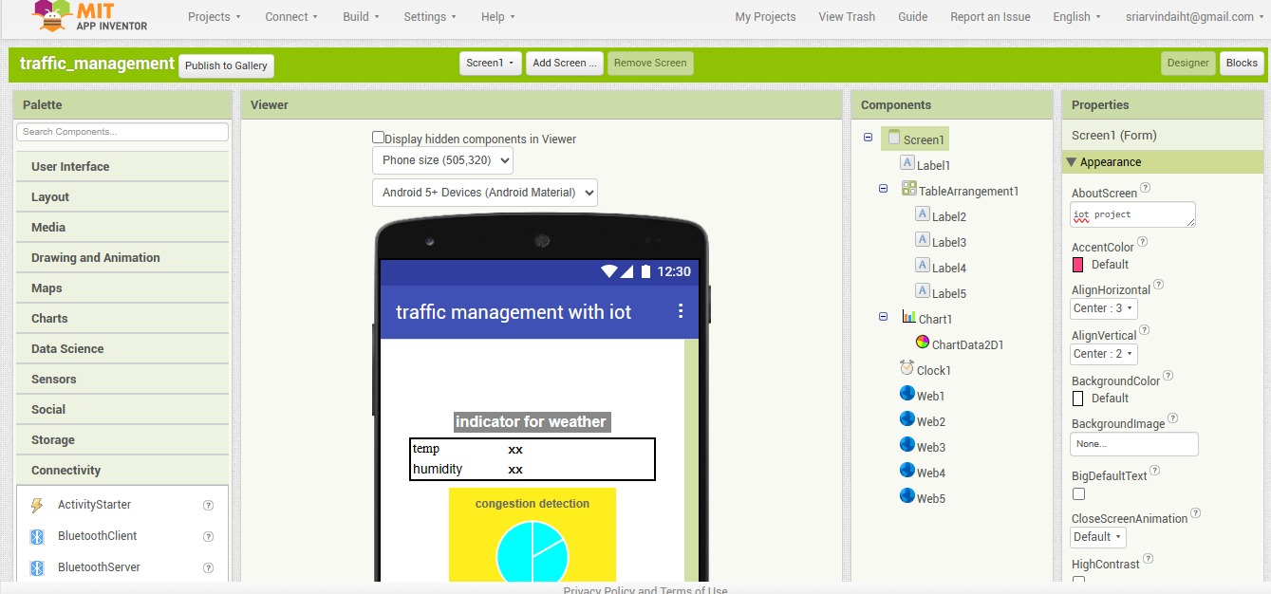

Here follows the block of code for MIT

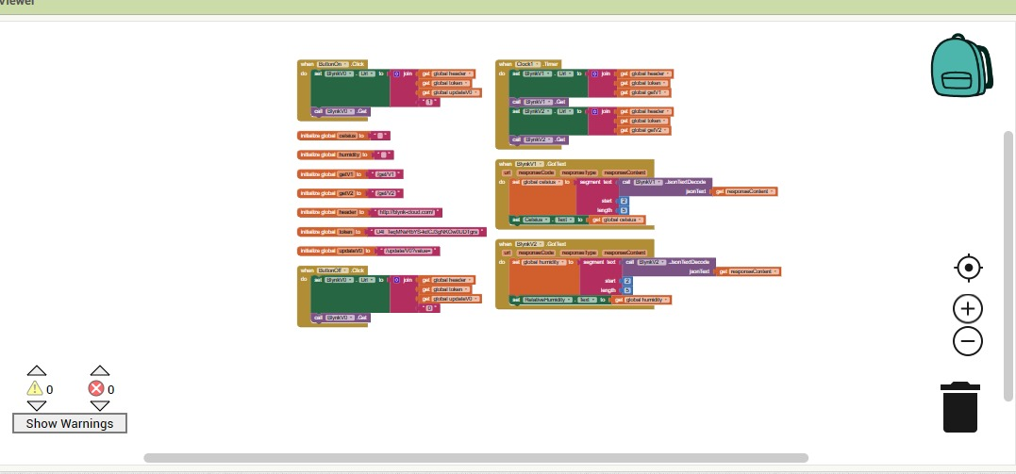

**CONCLUSION:**

In Phase 5, we have successfully culminated our IoT Traffic Management project, marking a significant milestone in our journey. With the seamless integration of cloud connectivity, we have elevated our traffic signal timing system to unprecedented levels of sophistication. By harnessing the power of real-time data analysis and optimization in the cloud, we have not only met but exceeded our initial objectives.

Through dynamic signal timing adjustments, our intelligent system has demonstrated its ability to effectively combat congestion and enhance traffic flow. This achievement has far-reaching implications for urban traffic management, promising safer and more efficient road networks for all members of our community.

The successful implementation of Phase 5 signifies the culmination of our collective efforts, dedication, and ingenuity. We have not only met our project goals but have also set the stage for future advancements in traffic management technology. As we reflect on this accomplishment, we recognize the transformative impact our project will have on urban mobility and the overall quality of life in our community.